<!DOCTYPE html>
<html>

<head>
<title>My Page</title> <!-- title of page -->
</head>

<body>
<h1 id=”myId”>Hello World</h1>
<p>This is a paragraph.</p>
<ul>
<li>Item 1</li>
<li>Item 2</li>
</ul>
</body>

</html>

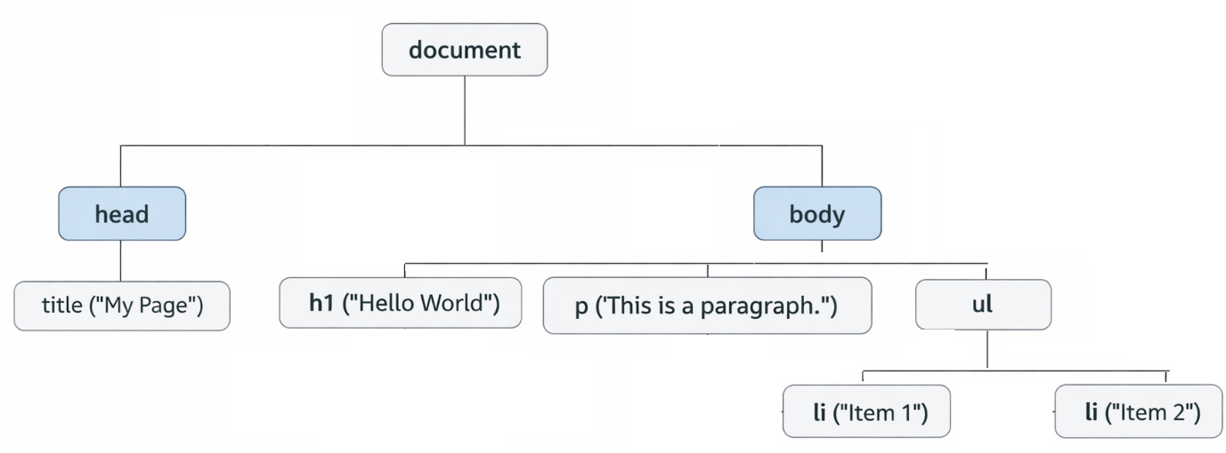

NOTE :

Node = any object in the DOM tree

Node Types
Node Type | Example
Element Node | <h1>, <p>, <ul>
Text Node | "Hello World", "Item 1"
Attribute Node | id="myId" (less used directly)
Comment Node | <!-- comment -->

Common nodeType values
Node Type | nodeType
Element Node | 1
Attribute Node | 2
Text Node | 3
Comment Node | 8
Document | 9
DocumentFragment | 11

Element = a specific type of Node(Only HTML/XML tags are Elements.)

Element Types
• <div>
• <span>
• <h1>
• <ul>, <li>

